**Name: Fatma Ahmed Atta**

**School Name: we Suez**

**Task Number:Unit4 Task1**

**Date:**

# Introduction

This report will discuss some of the important features of programming that include, among others, computational thinking, software applications, programming languages, programming constructs, logic, and how software quality plays an essential role in performance improvement. These aspects will be discussed in detail based on how these elements affect the process of successful development in programming.

**1.Computational Thinking**

**1.1** It is about how programmers take a big problem and solve it. Suppose you have a big problem; the first thing you would do is break it down into small pieces. Programmers do that, identify patterns, and then come up with designing solutions using algorithms.

**1.2** The programmer proceeds to a more specific stage after decomposition of the problem, where identification of common patterns in disparate problems recognizes and employs techniques of abstraction and decomposition to identify optimal solutions. This would help deal with complex problems much quicker and far more effectively.

**1.3** Higher order, computational thinking is more dynamic. Solutions by programmers reach a higher order where solutions adapt to data changes. This in return calls for advanced algorithms that learn from their previous experiences on how to improve their solution.

**2.Software Applications**

**2.1** Software applications are those that we use in everyday living to make things easier; for example, apps that help users schedule and manage their times better. This is to mean that tools are developed to solve specific problems or make our lives easier in one way or another.

**2.2** But that does not stop here. Improvements are always in the go to keep making the user experience easier and fine. Designing interactive and intuitive user interface makes efficient applications and amplifies urge of users to keep on using them.

**2.3** Advanced applications take it one step further; they are of high performance and with strong security, they provide smooth functionality on various devices and platforms. Many times, artificial intelligence is employed to deliver a user experience based on adjusting individual needs.

**3.Programming Languages**

**3.1** However, programming languages are just tools that programmers use to inform the computers about certain things. As an example, Python is used in developing on the Web and analyzing data, while Java is mainly applied in the development of mobile applications.

**3.2** There are usually variations among languages. For example, Java is strong on mobile applications, while Python excels in performing data analysis. The best choice really depends on the kind of problems we wish to solve when it comes to programming.

**3.3** Advanced programming, for selection, would be performance and efficiency-based. Sometimes, for the same projects, more than one programming language could be used by capitalizing on its best features to offer more effective and responsive solutions.

**4.Programming Constructs**

**4.1** Loops, conditionals, and functions are some of the basic building blocks of any program. These tools will enable programmers to attain the easy execution of instruction repetition and also to make decisions based on various conditions.

**4.2** If these tools are utilized accordingly, then the code becomes more readable and maintainable by programmers. The use of functions in order to avoid the repetition of code reduces errors and enhances the overall effectiveness of the program.

**4.3** Advanced programmers employ sophisticated structures in the form of nested loops and modular functions to develop advanced but extensible programs. These structures mean performance will be better with limited resource consumptions.

**5.Logic in Programming**

**5.1** Logic in programming makes certain that code works as anticipated. Programmers utilize conditions to check data and make proper decisions inside the program.

**5.2** The logic in programming may get complex with various mathematical operations and conditions. The programmers use the logic to verify more complicated decisions, such as checking the conditions of payment in a commercial website.

**5.3** In advanced programming, the logic in simple conditions develops to intelligent systems that may interact with changing data. Such a software applies artificial intelligence in making decisions according to various conditions.

**6.Quality of Software**

**6.1** Software quality is defined only by its usability and the speed at which the program responds. A well-written program should be easy to use and run fast, not lag.

**6.2** Speed cannot solely define quality; it needs to be effective on various devices as well as platforms. Good-quality software runs seamlessly on different devices and systems.

**6.3** The difference in this regard is that advanced software should easily be updated, secure, and high performance. Flexibility in software design allows developers to add new features and improvements without rewriting parts of the code.

# **7.restaurant-management-system(final product):**

**<https://github.com/topics/restaurant-management->system**



**7.1 Restaurant Management System:** This repository is meant to host a number of systems handling the operation of restaurants, from POS and menu management down to order processing, billing, and inventory. A few projects in development have been implemented using PHP, JavaScript, Python, and C++. They are divided into Web-based applications on one hand and desktop applications on the other. It also includes customers' tools interfacing to the customers on the web, for instance, table reservation systems and administration dashboards. Another area of concern is Aestheticism, where we can use covers for education, micro-operations, and full-scale a la caret systems.

**7.2 code: the code is simple , he put comment to every part and you can find what you are looking easily without any complexity.**

**After every part he doing space this made update not difficult**

**Because you can see the part you want to update.**

**7.3 software design on this final product: it work well and navigates between the pages doesn't have mistakes or glitches.**

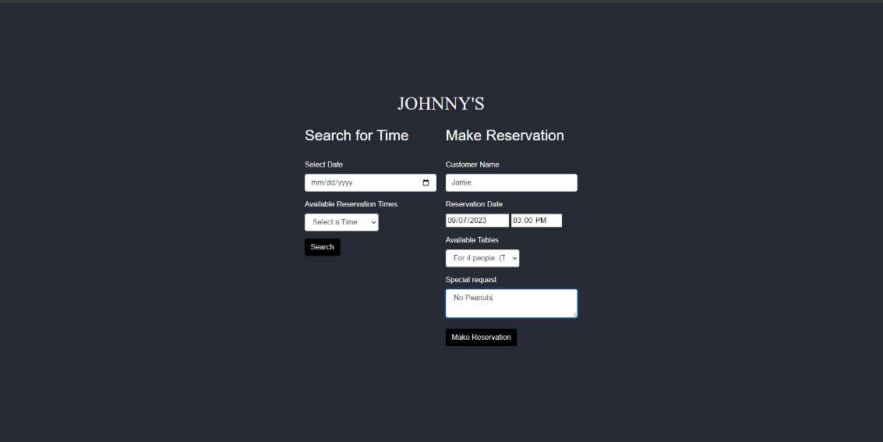

**In this page he could have developed it better than this, The user will feel confused because everything is combined and their places are very close. The user may make a mistake in writing something or put data in the wrong place.**

**He could have organized them better or used cards to organize them and make it easier for the user.**

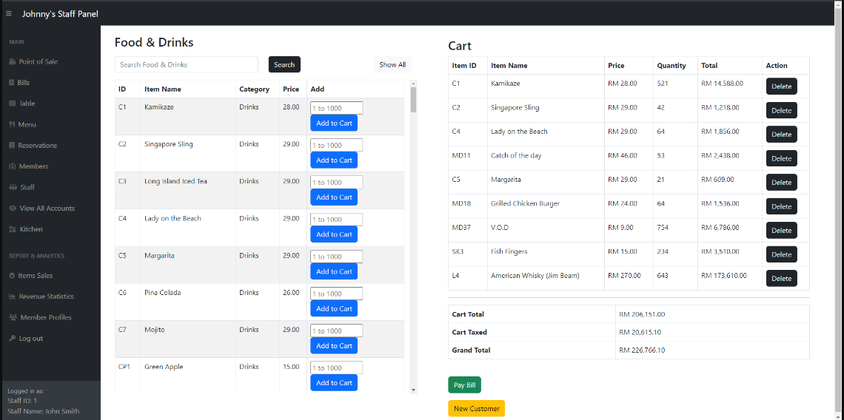

Here, he organized the data in a very wonderful way, and I used the language PHP and MySQL to implement this and put everything in its place. The person who receives the order can know all the information he needs without any problem with this good organization.

**Conclusion**

This report shows how computational thinking, programming languages, programming constructs, and software quality come into play. It also explores ways user experience can be enhanced and performance improved with smart algorithms and advanced programming techniques.nding of software development.